How to install python :

1. <https://www.python.org/downloads/>
2. Click on downloads🡪 windows

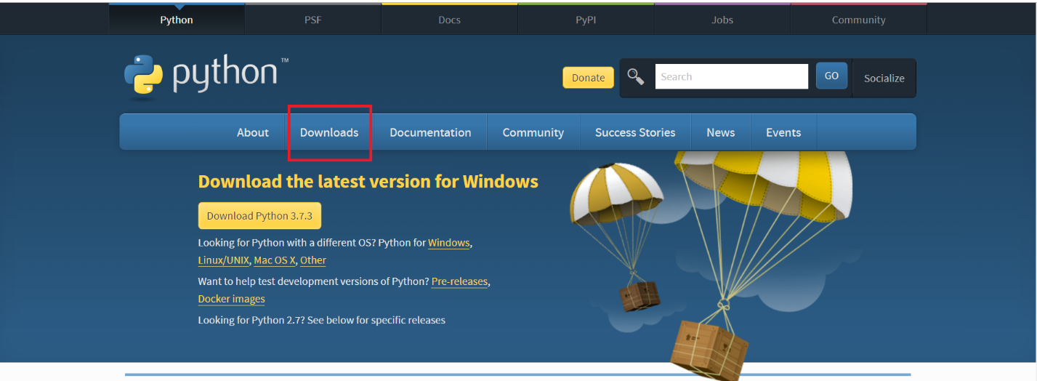

1. Click on latest python release as per below screenshot.

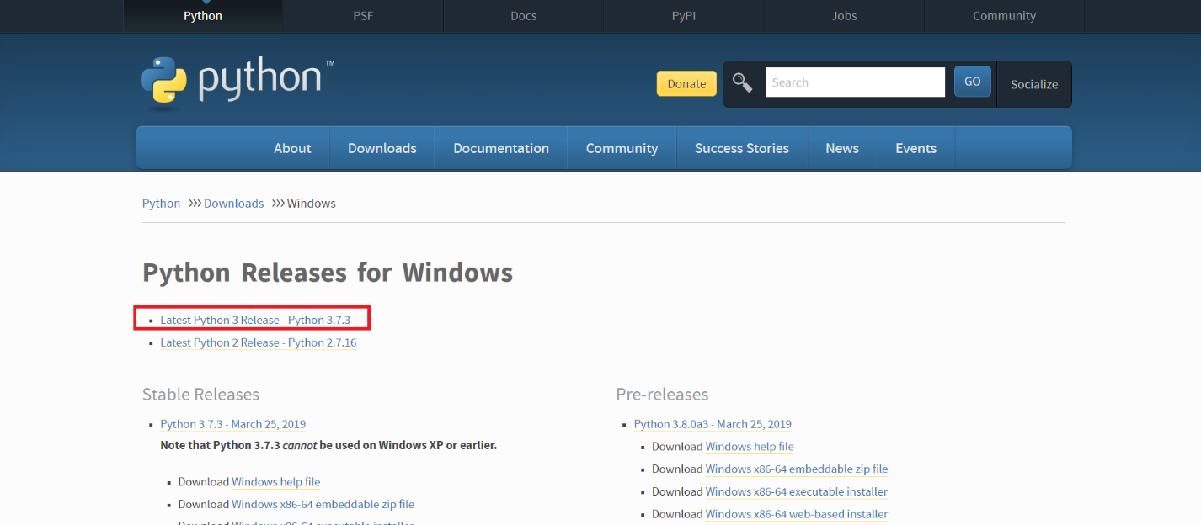

1. Scroll down and click on below link under ‘Files’ section.

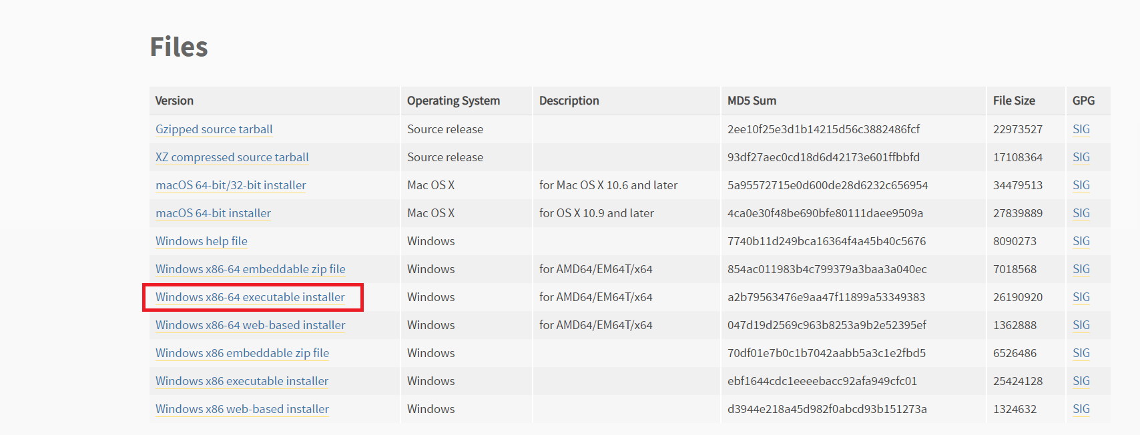

1. After downloading the installer , click on python.exe.

Note : Select the path check box displayed on the first page of installation.

1. Continue the process